Problem Solving – End of Unit Evaluation
Under each learning strand covered in this unit, describe what you have learned by using specific key words and key phrases in that learning strands. For each learning strand, discuss
- What went well? (WWW) – what have you learned and developed that you did not have at the start of this unit
- Even Better If… (EBI) – how you can improve your understanding even further
- Reflection - What could you improve? How/Why/Work Ethics/Targets?

Take a screenshot of your progress ladder bar chart and replace it below:
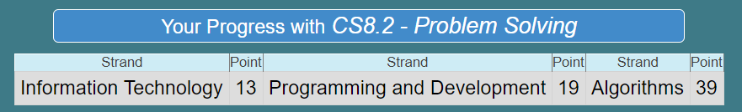
Algorithm
- I am able to explain the main steps in Computational Thinking:
  - Decomposition
  - Abstraction
  - Pattern Recognition
  - Algorithm Design
- I am able to use the steps above to find a solution to a problem.
- I am able to describe the four main shapes used in flowcharts and their purpose.
- I can use each step in Computational Thinking to actually solve problems when I am given them, like finding negative numbers or odd numbers in a list. Or making flowcharts to solve problems with mimics.
WWW: (use the above key words and key phrases in the above learning strand, remember to be specific)

EBI:

Programming and Development:
- I am able to define and explain the terms: sequencing, selection and iteration.
- I am able to turn a problem into pseudocode and then python code. Look back at your Week 2 and 3 tasks on Bourne to Learn for how you made a searching and a sorting algorithm.
- I am able to use sequencing, selection and iteration in python. I can explain what piece of code I need to write for each of the terms.
WWW: (use the above key words in bold and key phrases, remember to be specific)

EBI:

Information and Technology:
- I am able to use PowerPoint to create flowcharts using the design and drawing tools, making sure to use the correct shapes and drawing lines in the appropriate places.
- I can create, store and edit digital content using appropriate file and folder names.
- I can make improvements to work submitted based on feedback received from my teachers via BTL
- I can use a variety of software to manipulate and present digital content. (Scratch, Snipping tool, Paint, Word & BTC)
WWW: (use the above key words in bold and key phrases, remember to be specific)

EBI:

Reflection/Work Ethics/Targets - (Discuss how you work in class, do you put up your hand to answer question, do you get on with tasks when told or not?):

Grading of your work – Badges | Y/N
Bronze: Evaluated all learning strands of this unit but briefly.

Silver: Evaluated all learning strands of this unit with WWW and EBI on all strands.

Gold: Evaluated all learning strands with WWW and EBI on all strands with good use of punctuation, spelling & grammar.
Platinum: All the above, and included a self-reflection on work ethics.

