Storing Bits & Bytes

Non-volatile Memory (Silver)
SSD is called Solid State Drive. This is a form of non-volatile storage with no moving parts but with large capacity. It stores data by charging (1) or not charging (0) cells made of transistor and capacitors. It could have a capacity of 100 Terabytes.
Magnetic disks are ____ and they store bits by _____. They could have a capacity of______.
Optical discs are ___ and they store bits by _____. They could have a capacity of______.

How storing data on RAM works (Gold)
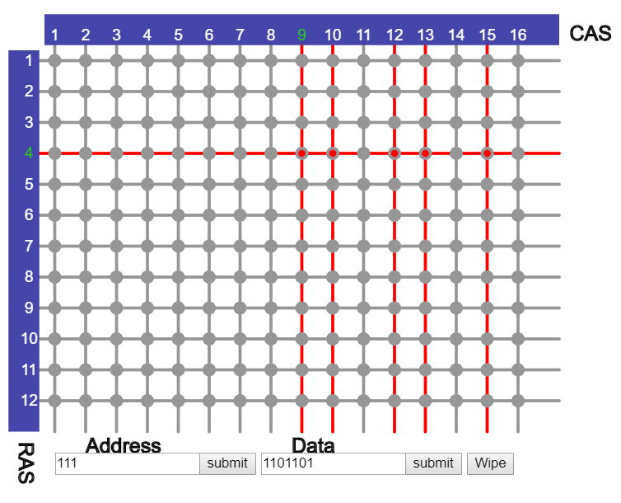
This is a memory cell – what is it made of?
Replace this text with what this number is in denary.
Replace this text with what this number is in denary.
Replace this text with what this number is in denary.
What is the green outline showing? What are the Red and Grey dots?

Use the above address and data, clues and hints above, describe how data can be stored in RAM.

How reading data from RAM works (Platinum)
Use the internet to conduct some research and learn how data can be read from the memory cells in RAM. Make sure you use your own words! Write at least 100 words.

